Project Design Phase-II Technology Stack (Architecture & Stack)

|  |  |
| --- | --- |
| Date | 16 October 2022 |
| Team ID | PNT2022TMID52729 |
| Project Name | Project - Web Phishing |
| Maximum Marks | 4 Marks |

# Technical Architecture:

The Deliverable shall include the architectural diagram as below and the information as per the table1 & table 2

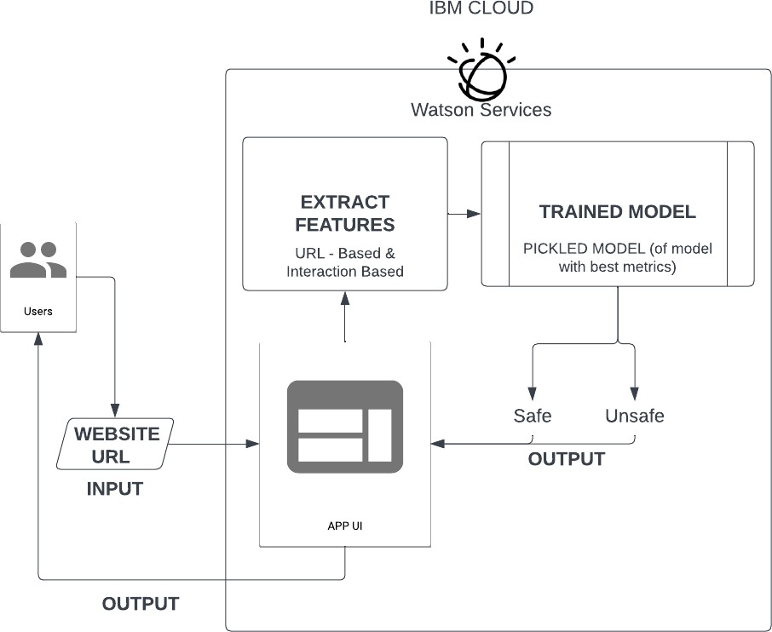

# Table-1 : Components & Technologies:

|  |  |  |  |
| --- | --- | --- | --- |
| **S.No** | **Component** | **Description** | **Technology** |
| 1. | User Interface | How user interacts with application e.g. Web UI, Mobile App, Chatbot etc. | HTML, CSS, Python - Flask |
| 2. | Website URL - Input | The URL of the site the user is suspicious of, or  wants to check whether it is safe or unsafe | HTML, CSS, Python - Flask |
| 3. | Website URL - Output | A prediction on whether the site is safe to use or if it is a phishing site | HTML, CSS, Python - Flask |
| 4. | APP UI | Logic for a process in the application | HTML, CSS, Python - Flask |
| 5. | Extract features | Extract the URL attributes, data type, Configurations, etc. | Python |
| 6. | Trained Model | Best metrics, accuracy, low FR, classify whether  attack or benign. | Python |
| 7. | Model Output | Classification whether it is safe or unsafe URL | Python, Jupyter Notebook |
| 8. | Infrastructure (Server / Cloud) - IBM | Application Deployment on Local System / Cloud Local Server Configuration:  Cloud Server Configuration : | IBM Cloud |

**Table-2: Application Characteristics:**

|  |  |  |  |
| --- | --- | --- | --- |
| **S.No** | **Characteristics** | **Description** | **Technology** |
| 1. | Scalable Architecture | Multi-tier architecture - connected to IBM cloud | Python |
| 2. | Availability | Cloud load balancing and storage in DB | IBM cloud services |
| 3. | Performance | Scalable to accommodate users and response time is reduced | Cloud App services, security modules and virtual hardware resources |